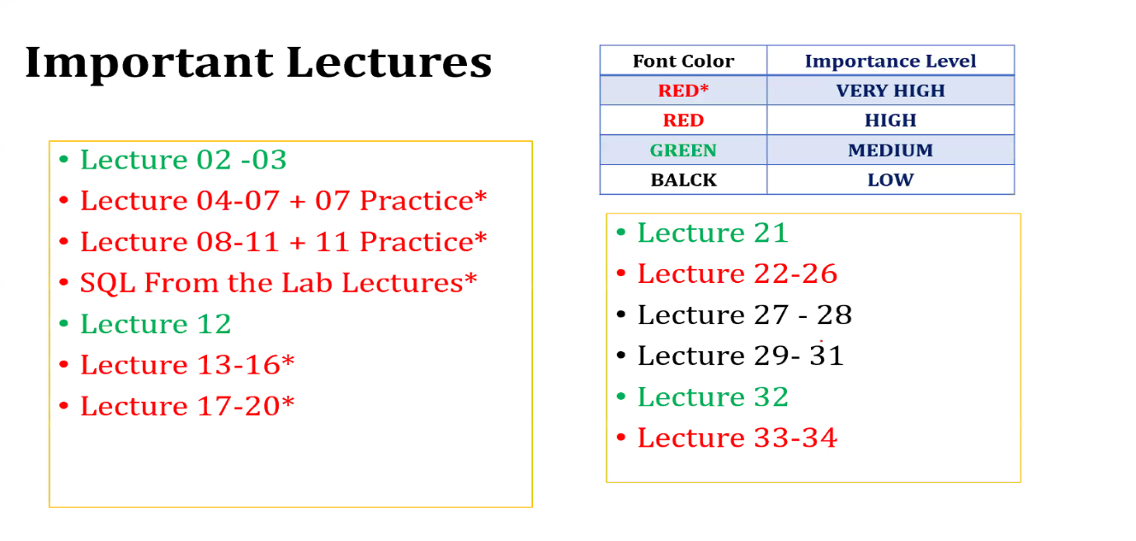

Quiz 01: Lecture 02 - Lecture 07

Quiz 02: Lecture 08 - Lecture 11

Quiz 03: Lecture 12 - Lecture 20

Quiz 04: Lecture 21 - Lecture 26

B Tree: https://www.cs.usfca.edu/~galles/visualization/BTree.html

B+ Tree: https://www.cs.usfca.edu/~galles/visualization/BPlusTree.html

Solution: https://www.db-book.com/db6/practice-exer-dir/index.html

Relational Algebra and Query practice

https://www.exploredatabase.com/2017/10/solved-exercises-in-dbms-answers-explained.html

Let’s look at each of the keys in DBMS with example: https://www.guru99.com/dbms-keys.html

Super Key – A super key is a group of single or multiple keys which identifies rows in a table.

Primary Key – is a column or group of columns in a table that uniquely identify every row in that table.

Candidate Key – is a set of attributes that uniquely identify tuples in a table. Candidate Key is a super key with no repeated attributes.

Alternate Key – is a column or group of columns in a table that uniquely identify every row in that table.

Foreign Key – is a column that creates a relationship between two tables. The purpose of foreign keys is to maintain data integrity and allow navigation between two different instances of an entity.

Composite Key – is a combination of two or more columns that uniquely identify rows in a table. The combination of columns guarantees uniqueness, though individual uniqueness is not guaranteed.

Compound Key – has two or more attributes that allow you to uniquely recognize a specific record. It is possible that each column may not be unique by itself within the database.

Surrogate Key – An artificial key which aims to uniquely identify each record is called a surrogate key. These kinds of key are unique because they are created when you don’t have any natural primary key.

The SQL language has several parts:

• Data-definition language (DDL). The SQL DDL provides commands for defining relation schemas, deleting relations, and modifying relation schemas.

• Data-manipulation language (DML). The SQL DML provides the ability to query information from the database and to insert tuples into, delete tuples from, and modify tuples in the database

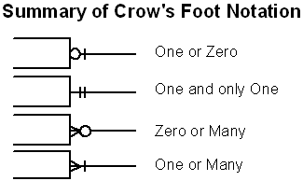

Relational algebra – solved exercise

|  |
| --- |
| Relational algebra operators:  σ – selection with conditions (It selects all tuples that satisfies the conditions. Shows entire table with respect to the structure)  Π – projection operator (It selects the attributes which are listed here)  ⨝ - natural join operator (Binary operator that join two relations on common attributes’ values)  -, ∪, and ∩ - set operators (difference, union and intersection) |

Question:

Consider the following relational database schema consisting of the four relation schemas:

passenger ( pid, pname, pgender, pcity)

agency ( aid, aname, acity)

flight (fid, fdate, time, src, dest)

booking (pid, aid, fid, fdate)

Answer the following questions using relational algebra queries;

Solution:

Most of the following queries can be written in many different ways.

a) Get the complete details of all flights to New Delhi.

σ destination = “New Delhi”(flight)

b) Get the details about all flights from Chennai to New Delhi.

σ src = “Chennai” ^ dest = “New Delhi” (flight)

c) Find only the flight numbers for passenger with pid 123 for flights to Chennai before 06/11/2020.

Πfid(σpid = 123(booking) ⨝ σdest = “Chennai” ^ fdate < 06/11/2020(flight))

[Hint: Given conditions are pid, dest, and fdate. To get the flight id for a passenger given a pid, we have two tables flight and booking to be joined with necessary conditions. From the result, the flight id can be projected]

d) Find the passenger names for passengers who have bookings on at least one flight.

Πpname(passenger ⨝ booking)

e) Find the passenger names for those who do not have any bookings in any flights.

Πpname((Πpid(passenger) - Πpid(booking)) ⨝ passenger)

[Hint: here applied a set difference operation. The set difference operation returns only pids that have no booking. The result is joined with passenger table to get the passenger names.]

f) Find the agency names for agencies that located in the same city as passenger with passenger id 123.

Πaname(agency ⨝acity = pcity(σpid = 123(passenger)))

[Hint: we performed a theta join on equality conditions (equi join) here. This is done between details of passenger 123 and the agency table to get the valid records where the city values are same. From the results, aname is projected.]

g) Get the details of flights that are scheduled on both dates 01/12/2020 and 02/12/2020 at 16:00 hours.

(σfdate = 01/12/2020 ^ time = 16:00(flight)) ∩ (σfdate = 02/12/2020 ^ time = 16:00(flight))

[Hint: the requirement is for flight details for both dates in common. Hence, set intersection is used between the temporary relations generated from application of various conditions.]

h) Get the details of flights that are scheduled on either of the dates 01/12/2020 or 02/12/2020 or both at 16:00 hours.

(σfdate = 01/12/2020 ^ time = 16:00(flight)) ∪ (σfdate = 02/12/2020 ^ time = 16:00(flight))

i) Find the agency names for agencies who do not have any bookings for passenger with id 123.

Πaname(agency ⨝ (Πaid(agency) – Πaid(σpid = 123(booking)))

j) Find the details of all male passengers who are associated with Jet agency.

Πpassengers.pid, pname, pcity(σpgender = “Male”(passengers ⨝ booking ⨝ agency))

[Hint: To get the link between passengers and agency, we need to join all three tables passengers, booking, and agency with necessary condition. Here, agency links both passengers and agency. As we have performed natural join operation between all three tables, the degree of the result will consist of all attributes from all the three tables. Hence, we project only passengers details as these are mentioned as required.]

**Basic Steps in Query Processing**

1. Parsing and translation
2. Optimization
3. Evaluation
4. **Parsing and translation**
5. Translate the query into its internal form. This is then translated into relational algebra.
6. Parser checks syntax, verifies relation.
7. **Optimization**
8. SQL is a very high level language:
9. The users specify what to search for- not how the search is actually done
10. The algorithms are chosen automatically by the DBMS.

* For a given SQL query there may be many possible execution plans.
* Amongst all equivalent plans choose the one with lowest cost.
* Cost is estimated using statistical information from the database catalog.
* **Evaluation**
* The query evaluation engine takes a query evaluation plan, executes that plan and returns the answer to that query.

With this information, let us write a query to find the list of all employees who are working in a project which is more than 10 months old.

**SELECT Ename**

**FROM Employee, Proj_Assigned**

**WHERE Employee.Eno = Proj_Assigned.Eno AND DOP > 10;**

**Input:**

A query written in SQL is given as input to the query processor. For our case, let us consider the SQL query written above.

**Step 1: Parsing**

In this step, the parser of the query processor module checks the syntax of the query, the user’s privileges to execute the query, the table names and attribute names, etc. The correct table names, attribute names and the privilege of the users can be taken from the system catalog (data dictionary).

**Step 2: Translation**

If we have written a valid query, then it is converted from high level language SQL to low level instruction in Relational Algebra.

For example, our SQL query can be converted into a Relational Algebra equivalent as follows;

πEname(σDOP>10 Λ Employee.Eno=Proj_Assigned.Eno(Employee X Prof_Assigned))

**Step 3: Optimizer**

Optimizer uses the statistical data stored as part of data dictionary. The statistical data are information about the size of the table, the length of records, the indexes created on the table, etc. Optimizer also checks for the conditions and conditional attributes which are parts of the query.

**Step 4: Execution Plan**

A query can be expressed in many ways. The query processor module, at this stage, using the information collected in step 3 to find different relational algebra expressions that are equivalent and return the result of the one which we have written already.

For our example, the query written in Relational algebra can also be written as the one given below;

πEname(Employee **⋈**Eno  (σDOP>10(Prof_Assigned)))

So far, we have got two execution plans. Only condition is that both plans should give the same result.

**Step 5: Evaluation**

Though we got many execution plans constructed through statistical data, though they return same result (obvious), they differ in terms of Time consumption to execute the query, or the Space required executing the query. Hence, it is mandatory choose one plan which obviously consumes less cost.

At this stage, we choose one execution plan of the several we have developed. This Execution plan accesses data from the database to give the final result.

In our example, the second plan may be good. In the first plan, we join two relations (costly operation) then apply the condition (conditions are considered as filters) on the joined relation. This consumes more time as well as space.

In the second plan, we filter one of the tables (Proj_Assigned) and the result is joined with the Employee table. This join may need to compare less number of records. Hence, the second plan is the best (with the information known, not always).

**Output:**

The final result is shown to the user.

# **ACID properties of transactions**

In the context of transaction processing, the acronym ACID refers to the four key properties of a transaction: atomicity, consistency, isolation, and durability.

**Atomicity**

All changes to data are performed as if they are a single operation. That is, all the changes are performed, or none of them are.

For example, in an application that transfers funds from one account to another, the atomicity property ensures that, if a debit is made successfully from one account, the corresponding credit is made to the other account.

**Consistency**

Data is in a consistent state when a transaction starts and when it ends.

For example, in an application that transfers funds from one account to another, the consistency property ensures that the total value of funds in both the accounts is the same at the start and end of each transaction.

**Isolation**

The intermediate state of a transaction is invisible to other transactions. As a result, transactions that run concurrently appear to be serialized.

For example, in an application that transfers funds from one account to another, the isolation property ensures that another transaction sees the transferred funds in one account or the other, but not in both, nor in neither.

**Durability**

After a transaction successfully completes, changes to data persist and are not undone, even in the event of a system failure.

For example, in an application that transfers funds from one account to another, the durability property ensures that the changes made to each account will not be reversed.

Link: [ACID properties of transactions - IBM Documentation](https://www.ibm.com/docs/en/cics-ts/5.4?topic=processing-acid-properties-transactions)

[Conflict Serializability in DBMS - GeeksforGeeks](https://www.geeksforgeeks.org/conflict-serializability-in-dbms/#:~:text=Conflict%20Serializable%3A%20A%20schedule%20is,on%20the%20same%20data%20item)

[Precedence Graph For Testing Conflict Serializability in DBMS - GeeksforGeeks](https://www.geeksforgeeks.org/precedence-graph-for-testing-conflict-serializability-in-dbms/)

Conflict Serializable: A schedule is called conflict serializable if it can be transformed into a serial schedule by swapping non-conflicting operations.

Conflicting operations: Two operations are said to be conflicting if all conditions satisfy:

* They belong to different transactions
* They operate on the same data item
* At Least one of them is a write operation

**Conflict Equivalent:** Two schedules are said to be conflict equivalent when one can be transformed to another by swapping non-conflicting operations.

What is Multilevel Index?

Multilevel Indexing in Database is created when a primary index does not fit in memory. In this type of indexing method, you can reduce the number of disk accesses to short any record and kept on a disk as a sequential file and create a sparse base on that file.

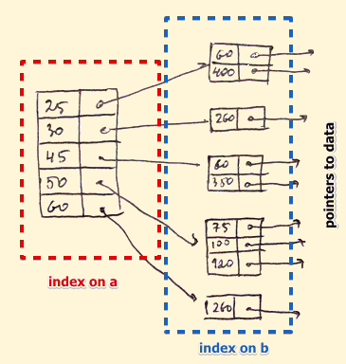

B-Tree Index

B-tree index is the widely used data structures for tree based indexing in DBMS. It is a multilevel format of tree based indexing in DBMS technique which has balanced [binary search trees](https://www.guru99.com/binary-search-tree-data-structure.html). All leaf nodes of the B tree signify actual data pointers.

Moreover, all leaf nodes are interlinked with a link list, which allows a B tree to support both random and sequential access.

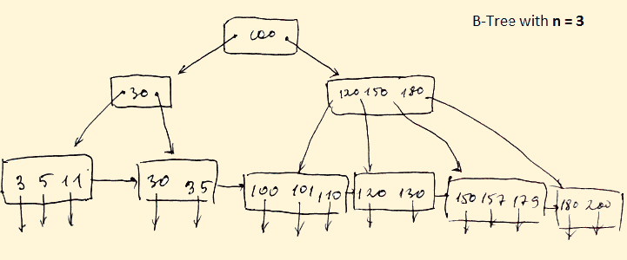

Lead nodes must have between 2 and 4 values.

Every path from the root to leaf are mostly on an equal length.

Non-leaf nodes apart from the root node have between 3 and 5 children nodes.

Every node which is not a root or a leaf has between n/2] and n children.

Advantages of Indexing

Important pros/ advantage of Indexing are:

It helps you to reduce the total number of I/O operations needed to retrieve that data, so you don’t need to access a row in the database from an index structure.

Offers Faster search and retrieval of data to users.

Indexing also helps you to reduce tablespace as you don’t need to link to a row in a table, as there is no need to store the ROWID in the Index. Thus you will able to reduce the tablespace.

You can’t sort data in the lead nodes as the value of the primary key classifies it.

Disadvantages of Indexing

Important drawbacks/cons of Indexing are:

To perform the indexing database management system, you need a primary key on the table with a unique value.

You can’t perform any other indexes in Database on the Indexed data.

You are not allowed to partition an index-organized table.

SQL Indexing Decrease performance in INSERT, DELETE, and UPDATE query.

Summary:

Indexing is a small table which is consist of two columns.

Two main types of indexing methods are 1)Primary Indexing 2) Secondary Indexing.

Primary Index is an ordered file which is fixed length size with two fields.

The primary Indexing is also further divided into two types 1)Dense Index 2)Sparse Index.

In a dense index, a record is created for every search key valued in the database.

A sparse indexing method helps you to resolve the issues of dense Indexing.

The secondary Index in DBMS is an indexing method whose search key specifies an order different from the sequential order of the file.

Clustering index is defined as an order data file.

Multilevel Indexing is created when a primary index does not fit in memory.

The biggest benefit of Indexing is that it helps you to reduce the total number of I/O operations needed to retrieve that data.

The biggest drawback to performing the indexing database management system, you need a primary key on the table with a unique value.

**B Tree**

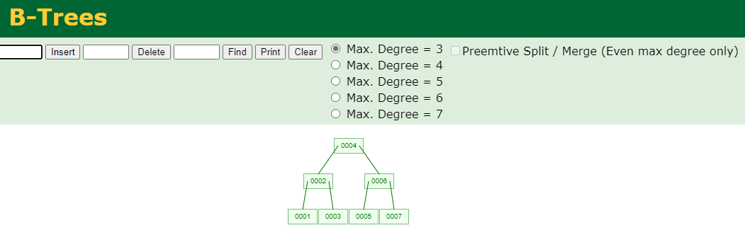

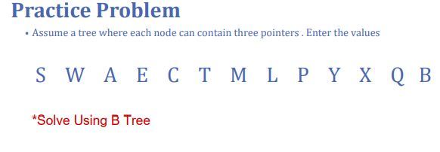

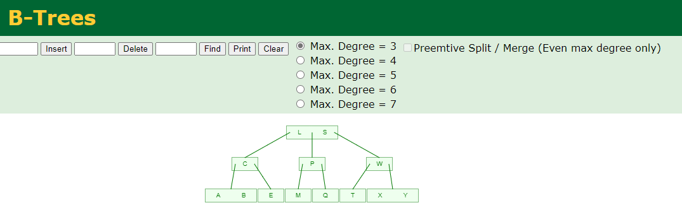

B+ Tree

Sorted Order: A C D F K L M N O P U X Y

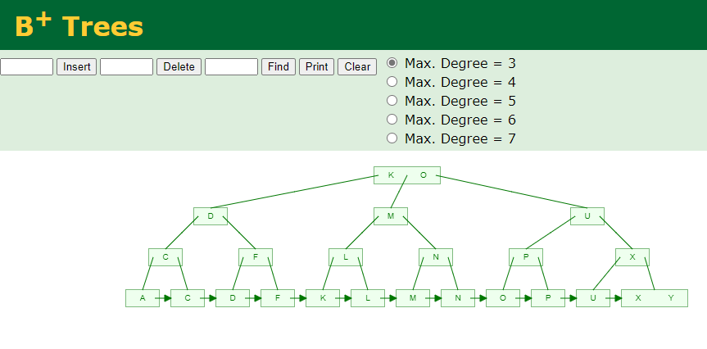

**Fragmentation in Distributed DBMS**

Fragmentation is a process of dividing the whole or full database into various subtables or sub relations so that data can be stored in different systems. The small pieces of sub relations or subtables are called fragments

In the fragmentation process, let’s say, If a table T is fragmented and is divided into a number of fragments say T1, T2, T3….TN.

Advantages :

As the data is stored close to the usage site, the efficiency of the database system will increase

Local query optimization methods are sufficient for some queries as the data is available locally

In order to maintain the security and privacy of the database system, fragmentation is advantageous

Disadvantages :

Access speeds may be very high if data from different fragments are needed

If we are using recursive fragmentation, then it will be very expensive

We have three methods for data fragmenting of a table:

Horizontal fragmentation

Vertical fragmentation

Mixed or Hybrid fragmentation

Let’s discuss them one by one.

**Horizontal fragmentation –**

Horizontal fragmentation refers to the process of dividing a table horizontally by assigning each row or (a group of rows) of relation to one or more fragments. These fragments are then be assigned to different sides in the distributed system. Some of the rows or tuples of the table are placed in one system and the rest are placed in other systems.

For example, consider an EMPLOYEE table (T) :

|  |  |  |  |  |
| --- | --- | --- | --- | --- |
| Eno | Ename | Design | Salary | Dep |
| 101 | A | abc | 3000 | 1 |
| 102 | B | abc | 4000 | 1 |
| 103 | C | abc | 5500 | 2 |
| 104 | D | abc | 5000 | 2 |
| 105 | E | abc | 2000 | 2 |

This EMPLOYEE table can be divided into different fragments like:

EMP 1 =  σDep = 1 EMPLOYEE

EMP 2 =  σDep = 2 EMPLOYEE

These two fragments are: T1 fragment of Dep = 1

|  |  |  |  |  |
| --- | --- | --- | --- | --- |
| Eno | Ename | Design | Salary | Dep |
| 101 | A | abc | 3000 | 1 |
| 102 | B | abc | 4000 | 1 |

Similarly, the T2 fragment on the basis of Dep = 2 will be :

|  |  |  |  |  |
| --- | --- | --- | --- | --- |
| Eno | Ename | Design | Salary | Dep |
| 103 | C | abc | 5500 | 2 |
| 104 | D | abc | 5000 | 2 |
| 105 | E | abc | 2000 | 2 |

Now, here it is possible to get back T as T = T1 ∪ T2 ∪ …. ∪ TN

**Vertical Fragmentation**

Vertical fragmentation refers to the process of decomposing a table vertically by attributes are columns. In this fragmentation, some of the attributes are stored in one system and the rest are stored in other systems.  This is because each site may not need all columns of a table.  In order to take care of restoration, each fragment must contain the primary key field(s) in a table.

For example, for the EMPLOYEE table we have T1 as :

|  |  |  |  |
| --- | --- | --- | --- |
| Eno | Ename | Design | Tuple_id |
| 101 | A | abc | 1 |
| 102 | B | abc | 2 |
| 103 | C | abc | 3 |
| 104 | D | abc | 4 |
| 105 | E | abc | 5 |

For the second. sub table of relation after vertical fragmentation is given as follows :

|  |  |  |
| --- | --- | --- |
| Salary | Dep | Tuple_id |
| 3000 | 1 | 1 |
| 4000 | 2 | 2 |
| 5500 | 3 | 3 |
| 5000 | 1 | 4 |
| 2000 | 4 | 5 |

This is T2 and to get back to the original T, we join these two fragments T1 and T2 as πEMPLOYEE (T1 ⋈ T2)

<https://www.geeksforgeeks.org/fragmentation-in-distributed-dbms/>

difference between Star and Snowflake Schema:

|  |  |  |
| --- | --- | --- |
| S.NO | Star Schema | Snowflake Schema |
| 1. | In star schema, The fact tables and the dimension tables are contained. | While in snowflake schema, The fact tables, dimension tables as well as sub dimension tables are contained. |
| 2. | Star schema is a top-down model. | While it is a bottom-up model. |
| 3. | Star schema uses more space. | While it uses less space. |
| 4. | It takes less time for the execution of queries. | While it takes more time than star schema for the execution of queries. |
| 5. | In star schema, Normalization is not used. | While in this, Both normalization and denormalization are used. |
| 6. | It’s design is very simple. | While it’s design is complex. |
| 7. | The query complexity of star schema is low. | While the query complexity of snowflake schema is higher than star schema. |
| 8. | It’s understanding is very simple. | While it’s understanding is difficult. |
| 9. | It has less number of foreign keys. | While it has more number of foreign keys. |
| 10. | It has high data redundancy. | While it has low data redundancy. |

